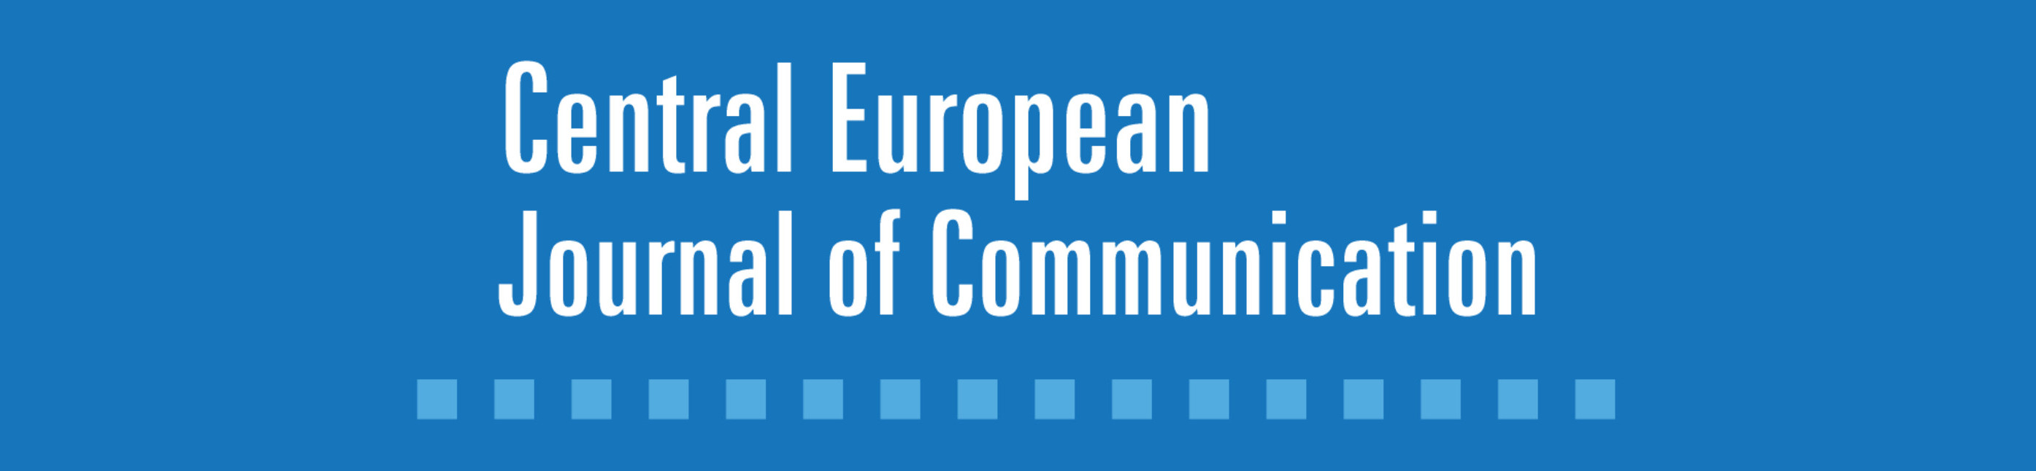 https://www.cejc.ptks.pl/

Central European Journal of Communication — 10 years on
Jubilee Conference
19 listopad 2018
Wrocław, Biblioteka Ossolineum, ul. Szewska 37, Sala Konferencyjna (wejście od strony ogrodu barokowego)

10.00-11.00 | OPENING SESSION: prof. dr hab. Iwona Hofman. President of Polish Communication Association  CENTRAL EUROPEAN JOURNAL OF COMMUNICATION TURNS 10  Speakers: Bogusława Dobek-Ostrowska (Editor-in-Chief), Michał Głowacki (Executive Editor), Paulina Barczyszyn-Madziarz (Scientific Database), Róża Norström (Submissions), Julia Trzcińska (Reviews )  THE BEST PHD` COMPETITION of POLISH COMMUNICATION ASSOCIATION  Prof. dr hab. Zbigniew Oniszczuk
11.00-11.30 | Coffee break, display of books and media/communications journals
11.30-13.00 | GUEST LECTURE BY PROF. DR. PAOLO MANCINI, University of Perugia, Italy  Central Europe in the perspective of the media systems studies.  Media Systems in Central Eastern Europe: Between Institutionalism and Culture
13:00-14:00 | Exposition of books and journals
14:00-15.30 | PLENARY SESSION: POSITIONING CENTRAL EUROPE IN GLOBAL MEDIA STUDIES  Chair: Bogusława Dobek-Ostrowska (University of Wrocław, Poland)  Speakers:  Peter Bajomi-Lazar, the Budapest Business School  The Maslow Pyramid of Journalism  Demeter Marton, Karoli Gaspar Universtiy of the Reformed Church in Hungary  The Global South’s Participation in the International Community of Communication Scholars: From an Eastern European Point of View  Jaromir Volek, Masaryk University in Brno, Czech Republic  Media Studies between Ideologiekritik and Critique of Information".  Bissera Zankova, "Media 21" Foundation, Bulgaria  Transition and media journals in Bulgaria
15.30-15.45 | Coffee break, display of books and media/communications journals
15.15-16.30 | JOURNALS` ROUNDTABLE: PUBLISHING IN CENTRAL EUROPE: MEDIA AND COMMUNICATION JOURNALS BETWEEN ANALOGUE AND DIGITAL  Chair: Michał Głowacki, Central European Journal of Communication, Poland  Participants:  KOME. An International Journal of Pure Communication Inquiry, Hungary - Marton Demeter  Medialni Studija, Czech Republic - Volek Jaromir  Media Biznes Kultura, Poland - Anna Ryłko-Kurpiewska  MEDIA-TEOLOGIA-KULTURA , Poland - Andrzej Adamski  Medijska istraživanja/Media Research, Croatia - Nadia Zgrablijić Rotar  Studia Medioznawcze, Poland  Studia Politologiczne, Poland  Zeszyty Prasoznawcze, Poland - Wojciech Kajtoch
16.30-17.00 | CLOSING SESSION:  Chair: Michał Głowacki  Roadmaps for Scientific Journal Publications: Discussion on Strategy for Central European Journal of Communication

